**ET380B程序下载使用说明**

**ET380B program download instructions**

**1. 配置 Configuration**

➢ PC端工具：MFToolSetA.exe（用于下载程序、数据） PC tool: MFToolSetA.exe (used to download programs and data)

➢ 终端设备： ET380 Terminal equipment: ET380

➢ 数据线：安卓手机数据线 Data cable: Android data cable

**2. 驱动安装 Driver Installation**

1. 双击运行驱动安装包中的自动安装脚本进行安装 Double-click to run the automatic installation script in the driver installation package to install



2. 驱动安装完成 Driver installation complete



**3. 程序下载 Program download**

**终端操作 Terminal operation**

1. 按住开机键，同时按【+】键，进入程序下载 Press and hold the power button and press [+] button at the same time to enter the program download

备注:进入程序下载时绿灯亮。Note: The green light is on when enter download mode

2. 使用安卓手机数据线连接终端与pc，打开pc设备管理器，查看终端与pc端通讯的端口号。Connect terminal to PC with Android data cable, open the device manager on PC, check the port number of communication.



**PC端操作 PC operation**

1. 运行下载工具MFToolSetA.exe ; Run the download tool MFToolSetA.exe

2. 选择程序下载，点击设置按钮，选择程序下载配置文件MsConfig.ini

Select the Program Download, then Config button, set configuration file MsConfig.ini to choose the program to download.

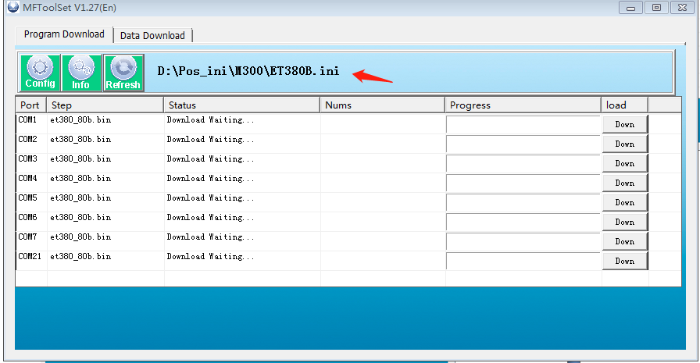

3. 选择终端与pc连接分配到的正确端口，点击下载 Select the correct port assigned to the terminal and pc connection, click download

下载中如下图： The download is as follows:

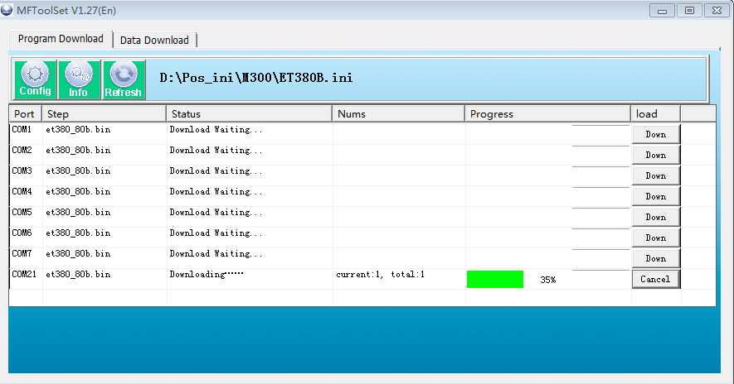

下载完成如下图：The download is completed as shown below:

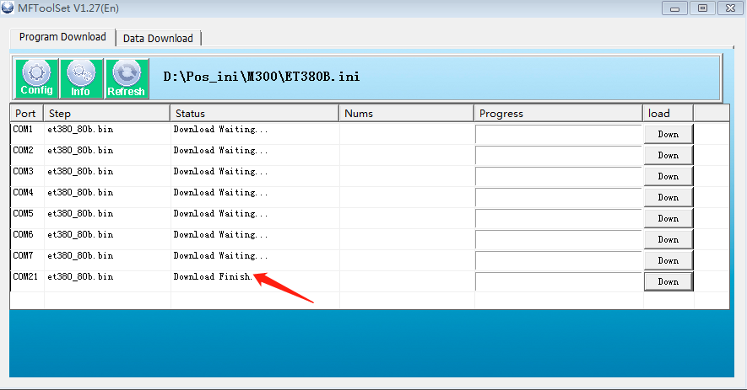

程序下载完成终端按任意键重启After the program is downloaded, press any key to restart the terminal